Maze Program Documentation

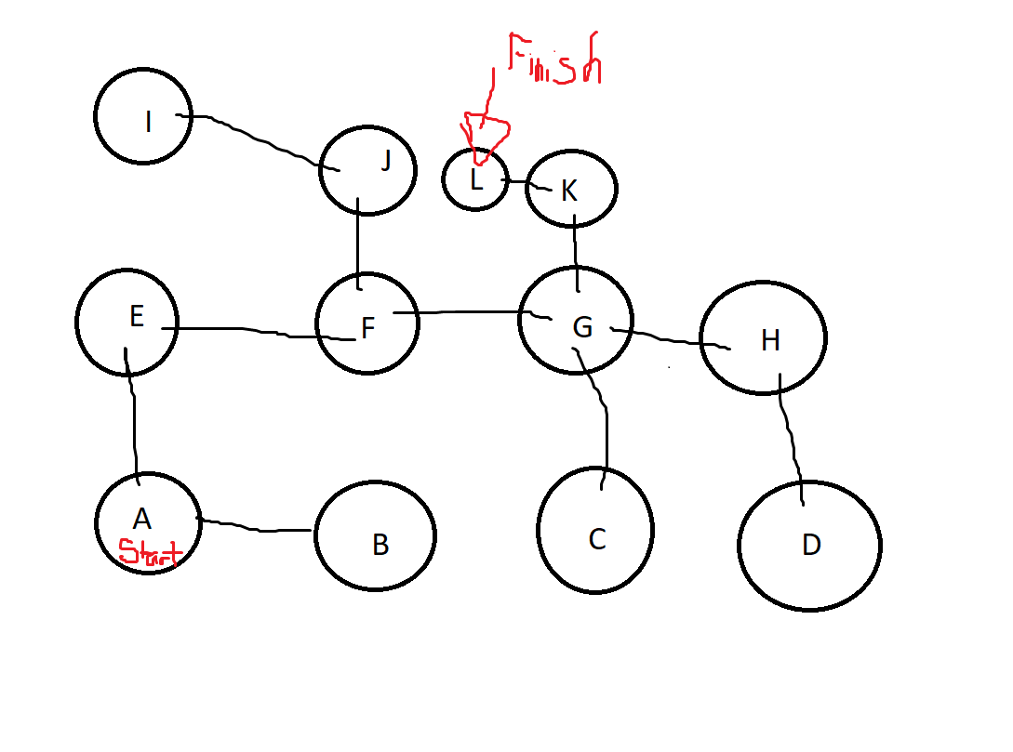
This picture represents the “Room map”, and which rooms are connected to which.
You will start in node A and the objective will be to finish in L.
When you start the program, you have to make sure that the file provided in the “Debug” folder called “Maze.txt” is in your C drive so it is able to run.

The following code I’m about to drop down, will be the hard code I used to make my program work.
My code consisted of 3 classes and 1 header.
The header is as its followed:
#ifndef MAZEHEADER_H
#define MAZEHEADER_H
#include <windows.h>
#include <stdio.h>
#include <tchar.h>
#include <vector>
#include <cstdlib>
#include <string>
#include <algorithm>
#include <iostream>
#include <fstream>

class Room
{
private:
std::string roomName; // town's name
Room* next; // link to next
public:
Room(); // no argument constructor
Room(std::string name, std::string ln, std::string le, std::string ls, std::string lw);
void setNext(Room* nextNode);

std::string getRoomProp();
bool getRoomExit(std::string m);
Room* getNext();
std::string getName();
std::string n, e, s, w;
};

class RoomList
{
private:
Room * start, *end;

public:
RoomList();
bool isEmpty();
void addFirstRoom(std::string name, std::string ln, std::string le, std::string ls, std::string lw);
void addRoomAtEnd(std::string name, std::string ln, std::string le, std::string ls, std::string lw);
void listAllNames();
void findRoom(std::string roomName);
void newFirstPositionRoom(std::string name, std::string ln, std::string le, std::string ls, std::string lw);
Room* getStart();
Room* getRoom(std::string __input, Room* CurrentRoom);

};
class FileReader
{
public:
std::string graphArray[12][5];
void ReadMaze(std::string file);

};
#endif

Followed by the MainClass.cpp, which was where the main was implemented:

#include "MazeHeader.h"

int main()
{
// Read from the file, the map
std::string FileName;
FileReader myMaze;
RoomList* mainList = new RoomList();
std::string userInput;

int stepCounter = 0;
std::string optionNorth;
std::string optionEast;
std::string optionSouth;
std::string optionWest;

//This will read from the folder "debug" which, you have to type "Maze" for it to work.
std::cout << "Before we start, please place the file 'Maze' within the debug folder inside your C: drive." << std::endl;
std::cout << "Please enter the name of the file: ";

getline(std::cin, FileName); // gets input from user to read the file
FileName += ".txt";
std::string fileLocation = "C:\\" + FileName;
myMaze.ReadMaze(fileLocation); // initialize the map

mainList->addFirstRoom(myMaze.graphArray[0][0], myMaze.graphArray[0][1], myMaze.graphArray[0][2], myMaze.graphArray[0][3], myMaze.graphArray[0][4]);
for (int s = 1; s <12; s++)
{
mainList->addRoomAtEnd(myMaze.graphArray[s][0], myMaze.graphArray[s][1], myMaze.graphArray[s][2], myMaze.graphArray[s][3], myMaze.graphArray[s][4]);
}

Room* currentPosition(mainList->getStart());

std::cout << "WELCOME TO THE MAZE, HAVE FUN!" << std::endl;
std::cout << "--------------------------------------------------" << std::endl;
std::cout << std::endl;

while (currentPosition->getName() != "L")
{

optionNorth = "";
optionEast = "";
optionSouth = "";
optionWest = "";

std::cout << "You are in room [" << currentPosition->getName() << "] of the maze." << std::endl;
std::cout << "Where do you want to go next?" << std::endl;

if (currentPosition->getRoomExit("n") == TRUE)
{
optionNorth = " (N)orth,";
}
if (currentPosition->getRoomExit("e") == TRUE)
{
optionEast = " (E)ast,";
}
if (currentPosition->getRoomExit("s") == TRUE)
{
optionSouth = " (S)outh,";
}
if (currentPosition->getRoomExit("w") == TRUE)
{
optionWest = " (W)est,";
}
std::cout << "You can go" << optionNorth << optionEast << optionSouth << optionWest << "or (Q)uit." << std::endl;
std::cin >> userInput;

if (userInput == "n" || userInput == "N")
{
if (currentPosition->getRoomExit("n") != TRUE)
{
std::cout << "Incorrect input." << std::endl;
}
else
{
currentPosition = mainList->getRoom("N", currentPosition);
}
}
if (userInput == "e" || userInput == "E")
{
if (currentPosition->getRoomExit("e") != TRUE)
{
std::cout << "Incorrect input." << std::endl;
}
else
{
currentPosition = mainList->getRoom("E", currentPosition);
}
}
if (userInput == "s" || userInput == "S")
{
if (currentPosition->getRoomExit("s") != TRUE)
{
std::cout << "Incorrect input." << std::endl;
}
else
{
currentPosition = mainList->getRoom("S", currentPosition);
}
}
if (userInput == "w" || userInput == "W")
{
if (currentPosition->getRoomExit("w") != TRUE)
{
std::cout << "Incorrect input." << std::endl;
}
else
{
currentPosition = mainList->getRoom("W", currentPosition);
}
}
if (userInput == "q" || userInput == "Q")
{
std::cout << "Thanks for playing." << std::endl;
std::cout << "You took " << stepCounter << " steps." << std::endl;
system("Pause");
exit(0);
}
std::cout << std::endl;
stepCounter++;

}
std::cout << "Congrats you won lol." << std::endl;
std::cout << "You took " << stepCounter << " steps." << std::endl;
system("PAUSE");
return 0;
}

And then followed by the FileReader.cpp class:
#include "MazeHeader.h"

void FileReader::ReadMaze(std::string localFileName)
{
std::string line;
std::ifstream mazeFile;
mazeFile.open(localFileName.c_str());
int test = mazeFile.peek();

int i = 0;
std::string nodeName;
std::string n, e, s, w;
int totalNodes = 0;
if (!(mazeFile.fail()))
{
while (mazeFile >> nodeName >> n >> e >> s >> w)//COUNTS FOR RESERVATION
{
graphArray[i][0] = nodeName;
graphArray[i][1] = n;
graphArray[i][2] = e;
graphArray[i][3] = s;
graphArray[i][4] = w;
i++;
}

}
else
{
std::cout << "The file name that was entered couldn't be opened." << std::endl;
exit(1);
}
}

And finally the class Room.cpp:

#include "MazeHeader.h"

Room::Room()
{

}

Room::Room(std::string name, std::string ln, std::string le, std::string ls, std::string lw)
{
roomName = std::string(name); // store name
this->n = ln;
this->e = le;
this->s = ls;
this->w = lw;
next = NULL; // initialise next
}

void Room::setNext(Room* nextNode)
{
next = nextNode; // change next node
}

Room* Room::getNext()
{
return next;
}

std::string Room::getRoomProp()
{
std::string line = this->roomName + n + e + s + w;

return line;
}

Room* RoomList::getRoom(std::string _input, Room* CurrentRoom)
{
std::string _room;
Room* current;
current = CurrentRoom;
if (_input == "N")
{
_room = current->n;
}
if (_input == "E")
{
_room = current->e;
}
if (_input == "S")
{
_room = current->s;
}
if (_input == "W")
{
_room = current->w;
}
while (current->getName() != _room)
{
if (current->getNext() == NULL)
{
current = start;
}
else
{
current = current->getNext();
}
}
return current;
}

RoomList::RoomList()
{
start = NULL; // both set to NULL
end = NULL;
}

bool RoomList::isEmpty()
{
return start == NULL;
}

void RoomList::addFirstRoom(std::string name, std::string ln, std::string le, std::string ls, std::string lw)
{
/*cout<<"Adding town "<<name <<" at start"<<endl<<endl;*/
Room* current;
current = new Room(name, ln, le, ls, lw); // allocate memory
start = current; // change start
end = current; // and end
}

void RoomList::addRoomAtEnd(std::string name, std::string ln, std::string le, std::string ls, std::string lw)
{
/* cout<<"Adding town "<<name << " at end"<<endl<<endl;*/

Room* current;

if (end == NULL) // if list is empty
addFirstRoom(name, ln, le, ls, lw);
else
{
current = new Room(name, ln, le, ls, lw); // allocate memory
end->setNext(current); // change end's next
end = current; // change end
}
}

Room* RoomList::getStart()
{
return this->start;
}
std::string Room::getName()
{
return this->roomName;
}
bool Room::getRoomExit(std::string i)
{
if (i == "n")
{
if (this->n != "*")
{
return TRUE;
}
}
if (i == "e")
{
if (this->e != "*")
{
return TRUE;
}

}
if (i == "s")
{
if (this->s != "*")
{
return TRUE;
}

}
if (i == "w")
{
if (this->w != "*")
{
return TRUE;
}
}
}
void RoomList::findRoom(std::string roomName)
{
Room* current;
current = start;
while (current->getName() != roomName)
{
current->getNext();
}
}
void RoomList::listAllNames()
{
Room* current;

if (!isEmpty())
{
std::cout << "Start of List" << std::endl;
current = start;
while (current != NULL)
{
// Funny syntax here as we have to de-reference a pointer to a pointer
std::cout << "Next town is: " << (current->getRoomProp()) << std::endl;
current = current->getNext();
}
std::cout << "End of List" << std::endl << std::endl;
}
else
std::cout << "List empty" << std::endl << std::endl;
}
void RoomList::newFirstPositionRoom(std::string name, std::string ln, std::string le, std::string ls, std::string lw)
{

if (end == NULL) // if list is empty
addFirstRoom(name, ln, le, ls, lw);
else
{
Room* current = new Room(name, ln, le, ls, lw); //Allocate new memory location for new object

current->setNext(start); //Set Current Object next pointer to start* Object
start = current; //Set start* to current object

}

}

